# Weekly Report

**Name :** Chitrala Dhruv

**Date of Submission :** 20th December 2020

**Reporting progress from :** 14th December to 20th December

* Solved the Recursion problems
* Learned about analogRead() and analogWrite()
* Learned about Pull up and Pull down Resistors
* Used LDR in TinkerCad and it’s voltage divider circuit
* Worked with IR sensors

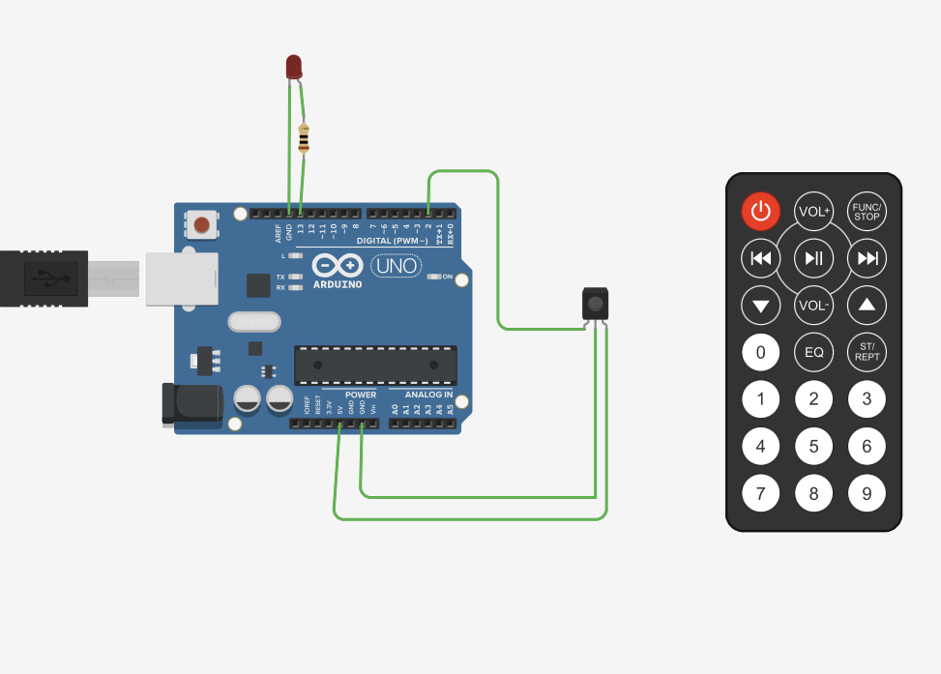

* Read about Arduino Shields
* Read about SPI Protocol for presentation